Automated software vulnerability
discovery, exploitation, and patching
Henry Post, hp2376@nyu.edu, NYU-CS-GY-6813

Hypothesis
In this paper, I propose a novel model of discovering, enumerating, exploiting, and patching software vulnerabilities, using taint analysis, abstract syntax tree parsing and exploit detection/confirmation using dynamic application security testing, and fuzzing with genetic algorithms.
I wish to also propose extensions to this model to react to external sources of information. To the current open-source ecosystem, publicly available vulnerability disclosure ecosystem, such as the NIST NVD, MITRE CVE, as well as harvesting proof-of-concept exploits from various databases.
There already exists a large number of papers covering how to parse application source code into tree structures [8] and analyze the “taint” introduced by handling user input through an application’s data flow. Below is a simplified example (fig. 2) of how the flow of an SQL Injection vulnerability could be detected by a method of Taint Analysis. The code can be seen in (fig. 1).
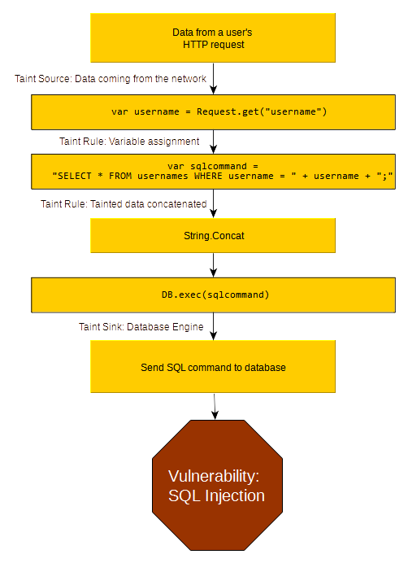Figure 1: A simplified example of Taint Analysis on the flow of data through a web application.
Figure 2: Source code vulnerable to SQL Injection.
var username = Request.get("username");

var sqlcommand = "SELECT * FROM usernames WHERE username = " + username + ";"

DB.exec(sqlcommand)

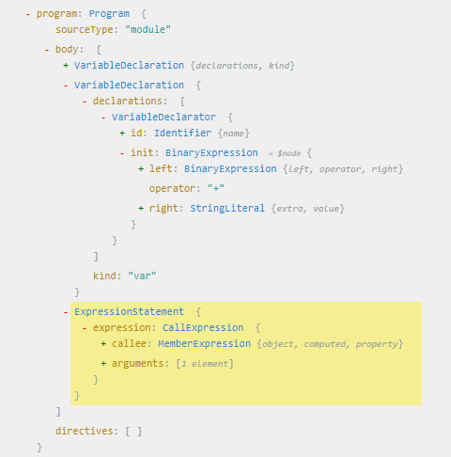Figure 3: A tree of the parsed source code, generated from https://astexplorer.net/

In (fig 3.), you can see the “+” operator shown to contain both the string literal “SELECT * FROM …” as well as the second binary expression (username + “;”). This tree structure allows the movement of the data from “Request.get()” to be tracked all the way to “DB.exec()” by making rules that track the flow of data through variables, assignment, transformations, and function calls.
There are a number of useful properties that parsing source code into an abstract syntax tree has. It allows you to extrapolate vulnerabilities by taking advantage of the properties of graphs as a data structure [4],[6],[7].
If we combine this static graph analysis approach with a dynamic application scanning approach, such as sending HTTP requests through some sort of fuzzing engine (such as SQLMap), we can marry the code parsing benefits of static tree analysis with the exploit-confirmation benefits of dynamic application security testing.
Once the code has been transformed into a tree structure, taint can be tracked, and vulnerabilities can also be extrapolated by analyzing patterns of code organization [8] and mutating them in order to generate new code graphs that “look similar to” known-exploitable sub-trees that exist within our code.
Once we have an analysis engine that can analyze the code as a graph, and its properties and trends, we can add another module to automate the patching of security vulnerabilities by leveraging “taint cleanse” rules (fig. 4). To build on the SQL Injection example, we would be able to automatically generate a code fix by suggesting we modify the code graph to include a “taint cleanse” node of “Parameterize Query” that would prevent the tainted data from reaching the database in an unsafe way.
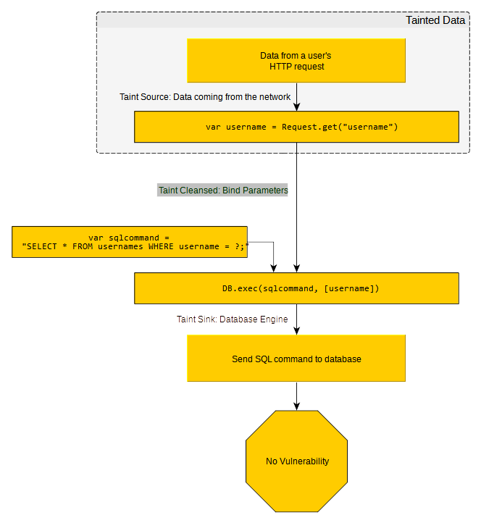Figure 4: An example of a "taint cleanse" rule, Bind Parameters, preventing tainted data from reaching a Taint Sink, the database.
We would be able to generate fixes automatically because of the nature of our analysis engine – Because the code is already in a tree format, we can fix vulnerabilities by performing operations on the graph itself (node swaps, node replacements, node deletion), and transforming the tree back into application source code.
We can also leverage databases such as NIST NVD and MITRE CVE to create new sources of taint within our application, or even across multiple applications, because we will be able to associate vulnerable components with specific CVEs.
This model of parsing source code, analyzing vulnerabilities, extrapolating vulnerabilities, and confirming vulnerabilities through dynamic testing is also extendable through machine learning [3] and by using genetic algorithms [8],[7],[6] to mutate properties. By taking these techniques and applying them to our proposed model of exploit detection and confirmation, we can create a model that should be able to detect a large number of obvious vulnerabilities, but also more difficult-to-detect vulnerabilities due to the large dataset of not only general-purpose machine learning datasets, but code as data, and therefore code trees as data.

References
- [1] Z. Wang, Y. Zhang, Z. Tian, Q. Ruan, T. Liu, H. Wang, Z. Liu, J. Lin, B. Fang, and W. Shi, “Automated Vulnerability Discovery and Exploitation in the Internet of Things,” Sensors, vol. 19, no. 15, p. 3362, Jul. 2019 [Online]. Available: http://dx.doi.org/10.3390/s19153362

- [2] “Vulnerability scanning of IOT devices in Jordan using SHODAN,” IEEE Xplore. [Online]. Available: https://ieeexplore.ieee.org/document/8277814.

- [3] “The Coming Era of alphahacking?: A survey of automatic software vulnerability detection, exploitation and patching techniques,” IEEE Xplore. [Online]. Available: https://ieeexplore.ieee.org/abstract/document/8411838.
- [4] “A machine learning-based approach for automated vulnerability remediation analysis,” IEEE Xplore. [Online]. Available: https://ieeexplore.ieee.org/abstract/document/9162309.
- [5] “Robot hacking games,” Center for Security and Emerging Technology, 05-Oct-2021. [Online]. Available: https://cset.georgetown.edu/publication/robot-hacking-games/.
- [6] “Automated vulnerability analysis: Leveraging control flow for evolutionary input crafting,” IEEE Xplore. [Online]. Available: https://ieeexplore.ieee.org/document/4413013.
- [7] Kameleonfuzz: Evolutionary fuzzing for black-box XSS detection. (n.d.). Retrieved October 24, 2021, from https://www.researchgate.net/publication/259175145_KameleonFuzz_Evolutionary_Fuzzing_for_Black-Box_XSS_Detection.
- [8] F. Yamaguchi, A. Maier, H. Gascon and K. Rieck, "Automatic Inference of Search Patterns for Taint-Style Vulnerabilities," 2015 IEEE Symposium on Security and Privacy, 2015, pp. 797-812, doi: 10.1109/SP.2015.54.

